

Map Brief description:  
**Today,  
we retake our Legacy.**

**And with it,  
our Legends.**

The commanders who enter an ancient temple discover an old legacy and divide their forces to compete for it.

# Ⅱ. Commanders Setting

It is a 5 vs 5 progression and the commander per team consists of

1. Vanguard Commander
2. Central Commander
3. Weapon Commander
4. Tactical Operation Commander
5. Air Support Commander

The specifications of the commanders' units are all set to campaign versions. Some fraudulent or underutilized skills were randomly touched. Among them, the Vanguard, Central, and Weapon Commanders are the Main Commanders, and the basic unit settings are as follows.

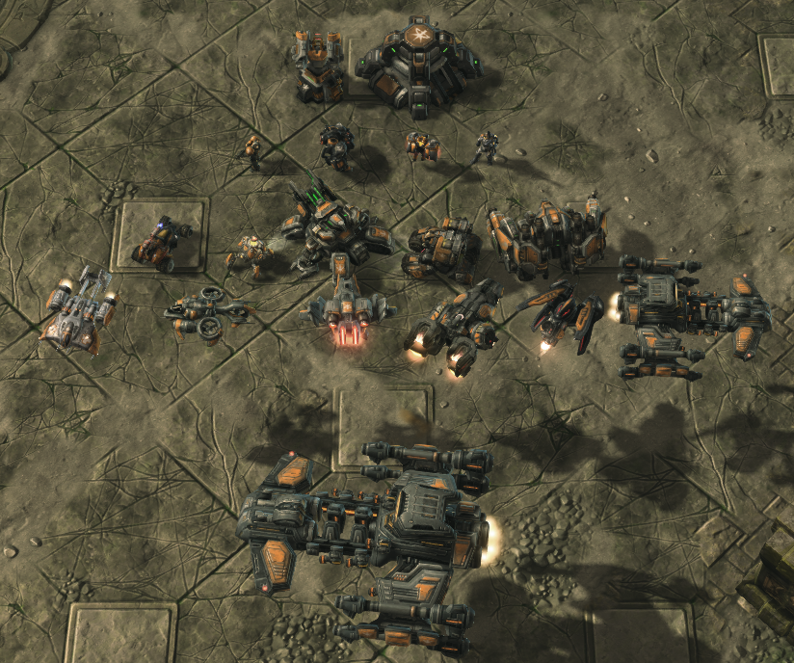

|  |  |  |  |  |  |
| --- | --- | --- | --- | --- | --- |
| Terran - Main Commander | | | | | |
| Structure | Missile Turret | Bunker |  |  |  |
| Barracks | Marine | Marauder | Reaper | Ghost |  |
| Factory | Hellion | Widow Mine | Siege Tank | Cyclone | Thor |
| Starport | Medivac | Banshee | Viking | Liberator | Battlecruiser |
|  | Raven |  |  |  |  |
| Ultimate Unit  (Starport) | Control Cruiser(Base: Battlecruiser)  (Yamato Cannon)(Tactical Jump)(Scanner Sweep)(Radar)(32 troop transport)  (Only one) | | | | |

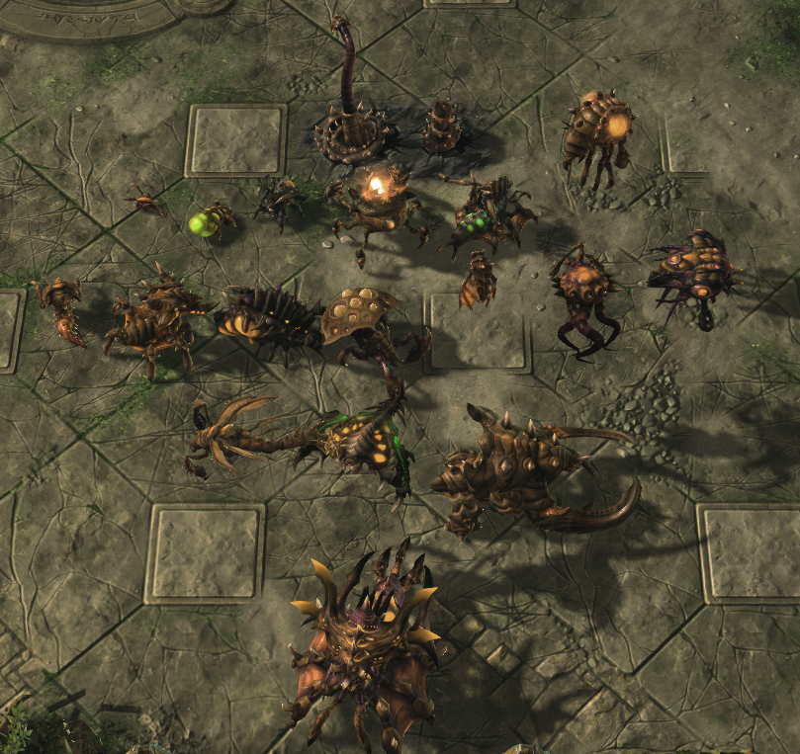

|  |  |  |  |  |  |  |  |
| --- | --- | --- | --- | --- | --- | --- | --- |
| Zerg - Main Commander | | | | | | | |
| Structure | Spine Crawler | | Spore Crawler | | | | |
| Hatchery | Zergling | Baneling | Roach | Ravager | Queen | | Overlord |
| Lair | Hydralisk | Lurker | Infestor | Mutalisk | Swarm Host | | Corruptor |
|  | Overseer |  |  |  |  | |  |
| Hive | Brood Lord | | Ultralisk | | | Viper | |
| Ultimate  Unit (Hive) | Niadra  (Spawn Zergling, Roach, Hydra, and Ultralisk Eggs)(Regeneration Aura)(Only one) | | | | | | |

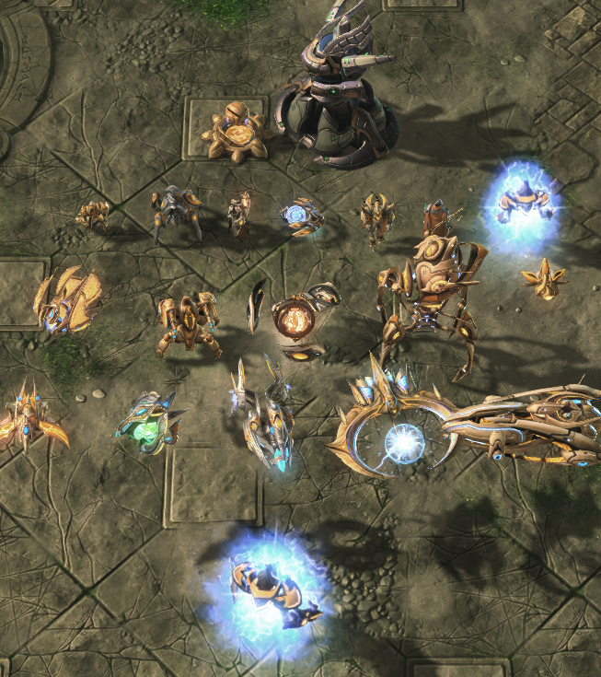

|  |  |  |  |  |  |
| --- | --- | --- | --- | --- | --- |
| Protoss - Main Commander | | | | | |
| Structure | Photon Cannon | | Khaydarin Monolith | | |
| Gateway | Zealot | Stalker | Sentry | Adept | Archon |
|  | High Templar | Dark Templar |  |  |  |
| Robotics Facility | Warp Prism | Immortal | Colossus | Disruptor | Observer |
| Stargate | Phoenix | Oracle | Void Ray | Tempest | Carrier |
| Ultimate Unit  (Gateway) | Twilight Archon(Base: Archon)  (Shadow Charge)(Unlimit on number) | | | | |

Additional Information

Vangaurd, Weapon Commander:  
The Vanguard's armor is increased by 2, and the Weapon's weapon is increased by 2.  
It has a supply limit of 180.  
The expansion base is exposed to the outside.

Central Commander:  
Basically 1 up weapon and 1 up armor.  
Has a supply limit of 200.  
The largest area.  
This base includes an expansion base.

The Tactical Operations Commander's basic unit settings are as follows:

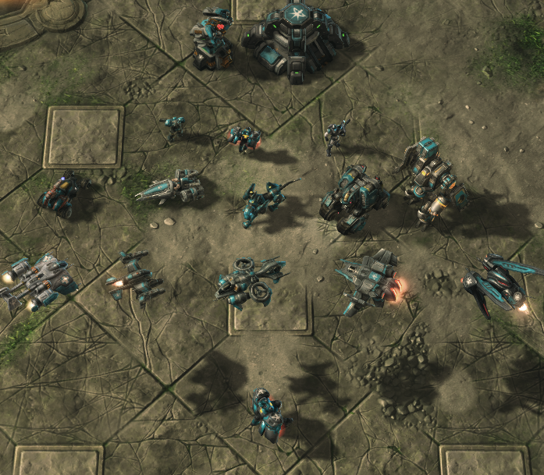

|  |  |  |  |  |  |
| --- | --- | --- | --- | --- | --- |
| Terran - Sub-Commander(Tactical Operation) | | | | | |
| Structure | Missile Turret | Bunker |  |  |  |
| Barracks | Marine | Reaper | Ghost |  |  |
| Factory | Hellion | Vulture | Predator  (Cloak) | Cyclone | Warhound |
| Starport | Medivac | Wraith | Banshee | Viking | Ravon |
| Ultimate Unit  (Barracks) | Unknown(Base: Reaper)  (Jet Pack)(EMP)(Combat Drugs)(Tac Nuke Strike)(Cloak)(Only One) | | | | |

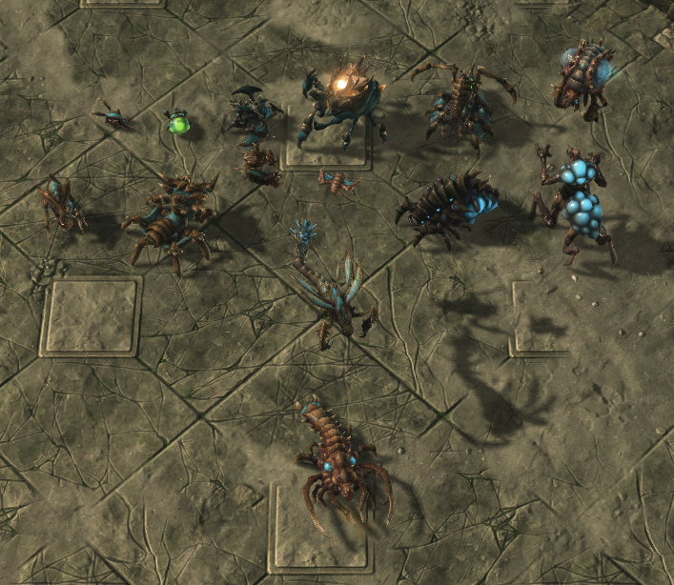

|  |  |  |  |  |  |  |  |
| --- | --- | --- | --- | --- | --- | --- | --- |
| Zerg - Sub-Commander(Tactical Operation) | | | | | | | |
| Structure | Spine Crawler | | Spore Crawler | | | | |
| Hatchery | Zergling | Baneling | Roach | Ravager | Queen | | Overlord |
| Lair | Hydralisk | Lurker | Infestor | Mutalisk | Scourge | | Overseer |
|  | Aberration |  |  |  |  | |  |
| Hive | Viper | |  | | |  | |
| Ultimate  Unit (Hive) | Dustylisk(Base: Defiler)  (Dark Swarm)(Plague)(Consume)(Deep Burrow)(Only One) | | | | | | |

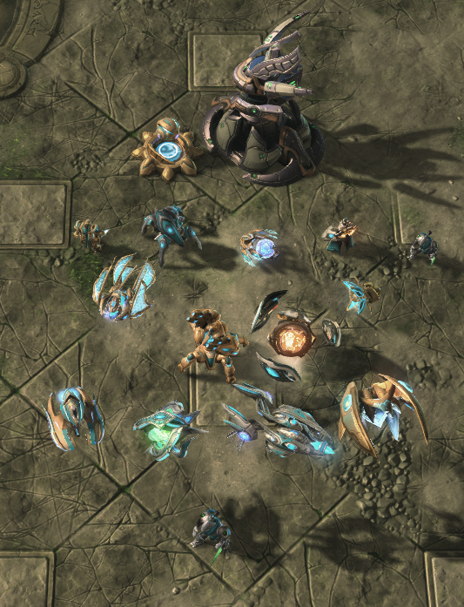

|  |  |  |  |  |  |
| --- | --- | --- | --- | --- | --- |
| Protoss - Sub-Commander(Tactical Operation) | | | | | |
| Structure | Photon Cannon | | Khaydarin Monolith | | |
| Gateway | Zealot | Stalker | Sentry | Adept | Dark Templar |
| Robotics Facility | Warp Prism | Immortal | Disruptor | Observer |  |
| Stargate | Corsair | Oracle | Void Ray | Arbiter |  |
| Ultimate Unit  (Gateway) | Successor(Base: Dark Templar)  (Permanent Cloaked)(Shadow Stride)(Psionic Storm)(Only One) | | | | |

Additional Information

Basically 1 up weapon.  
Has a supply limit of 150.  
Only One Base  
4 rich mineral fields, 4 general mineral field, 1 rich vespene gas, 1 general vespene gas.

The Air Support Commander's basic unit settings are as follows:

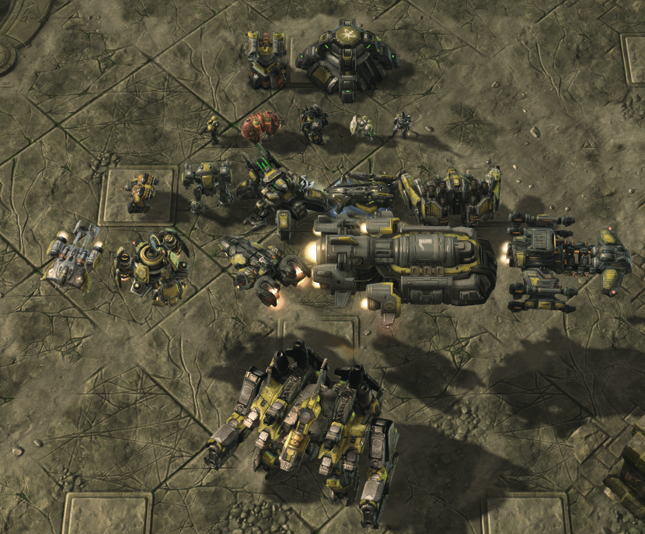

|  |  |  |  |  |  |
| --- | --- | --- | --- | --- | --- |
| Terran - Sub-Commander(Air Support) | | | | | |
| Structure | Missile Turret | Bunker |  |  |  |
| Barracks | Marine | Marauder | Firebat | Medic | Ghost |
| Factory | HERC | Goliath | Crucio Siege Tank | Diamondback | Thor |
| Starport | Medivac | Science Vessel | Liberator | Hercules-class Dropship  (Odin) | Battlecruiser |
| Ultimate Unit  (Factory) | Odin(Although it is the air support commander, it is selected as weapon and defense support because support is already sufficient with medivac and science vessle.)(330mm Barrage)(Only One) | | | | |

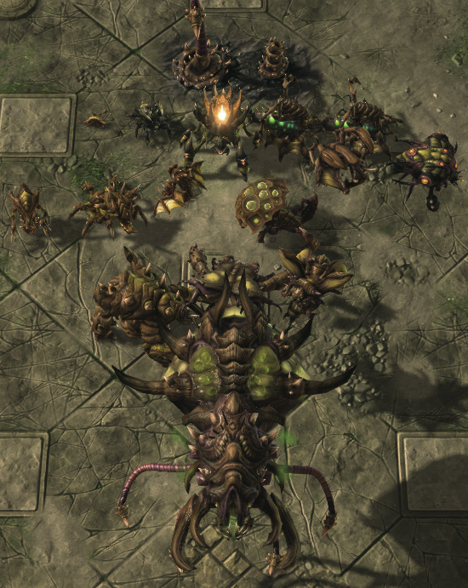

|  |  |  |  |  |  |  |  |
| --- | --- | --- | --- | --- | --- | --- | --- |
| Zerg - Sub-Commander(Tactical Operation) | | | | | | | |
| Structure | Spine Crawler | | Spore Crawler | | | | |
| Hatchery | Zergling | Baneling | Roach | Ravager | Queen  (+Morph  Larva) | | Overlord |
| Lair | Hydralisk | Lurker | Mutalisk | Swarm Host | Queen  (Classic) | | Overseer |
| Hive | Ultralisk | | Guardian | | | Devourer | |
| Ultimate  Unit (Hive) | Megalord(Base: Leviathan)  (Bio-Plasmid Discharge)(Bio-Stasis)(Wild Mutation)(Only One) | | | | | | |

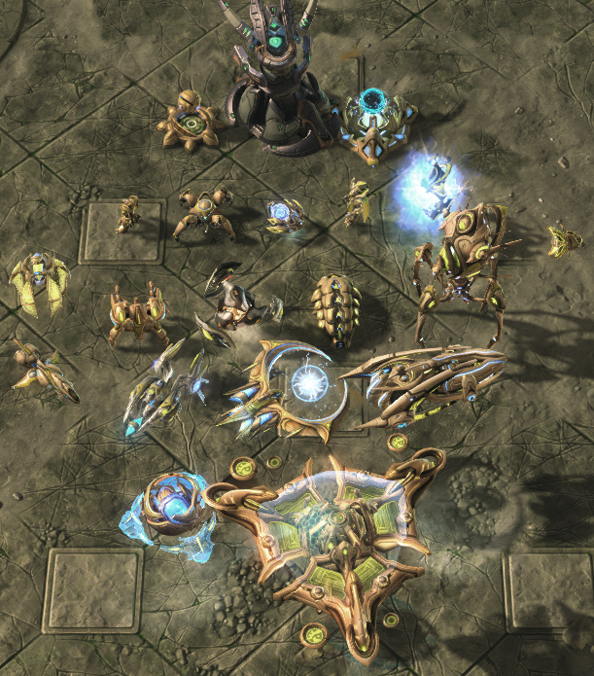

|  |  |  |  |  |  |  |
| --- | --- | --- | --- | --- | --- | --- |
| Protoss - Sub-Commander(Tactical Operation) | | | | | | |
| Structure | Photon Cannon | | Khaydarin Monolith | | Shield Battery | |
| Gateway | Zealot | Dragoon | Sentry | High Templar | | Archon |
| Robotics Facility | Warp Prism | Immortal | Colossus | Disruptor | Reaver | Observer |
| Stargate | Scout | Void Ray | Tempest | Carrier |  |  |
| Ultimate Unit  (Gateway) | Mothership Core  (Time Warp)(Mass Recall)(Repair Drone)(Guardian Shield)(Only One)  Mothership  (Time Warp)(Mass Recall)(Repair Drone)(Photon Overcharge)(Enhancing Guardian Shield)(Only One) | | | | | |

Additional Information

Basically 1 up armor.  
Has a supply limit of 150.  
Only One Base  
4 rich mineral fields, 4 general mineral field, 1 rich vespene gas, 1 general vespene gas.

Additional Information - Protoss Support Unit & Structure

Removes Sentry’s Guardian Shield. Instead, it gains the abilities of Shield Battery.

As the function of the Shield Battery is transferred to the Sentry, the structure will be deleted. However, due to the nature of this game, base defense needs to be maximized in the second half, so I replace it with Khaydarin Monolith.

The Sentry's Guardian Shield is transferred to the Air Support Commander's Mothership Core and Mothership. It asks whether the Mothership will defend the base with Photon Overcharge or support the front line with a Guardian Shield.

# Ⅲ. Element

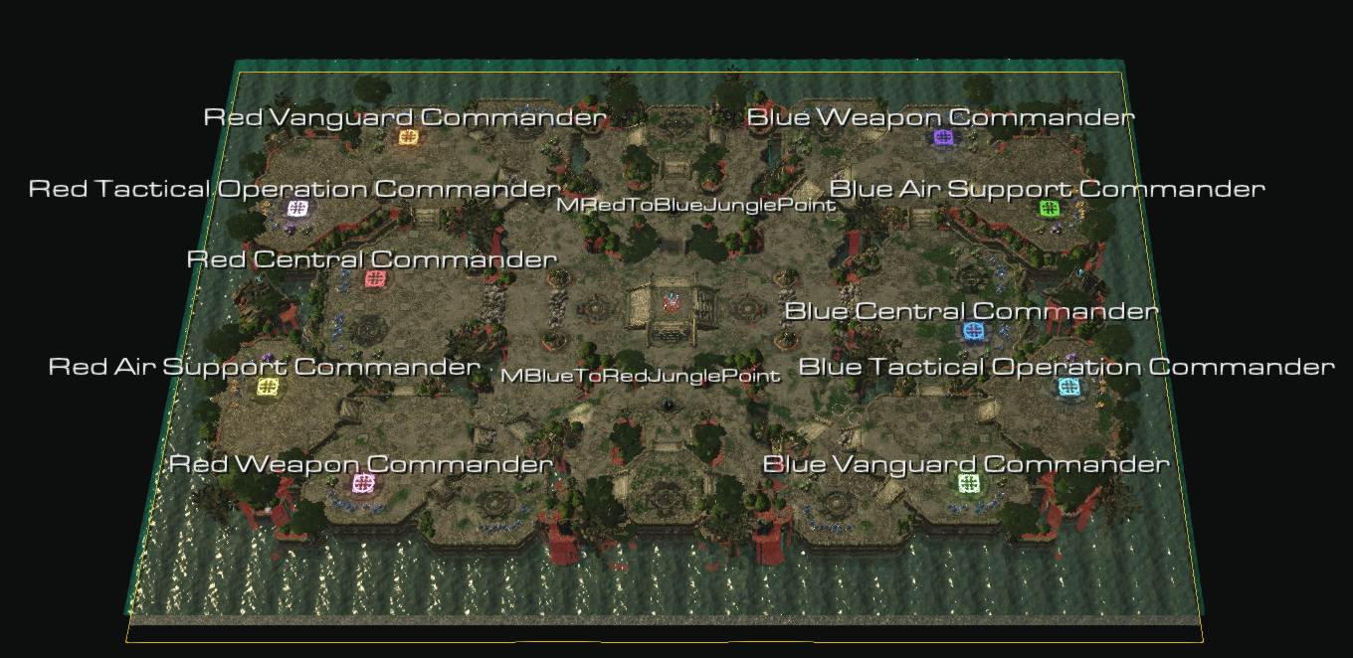

Foreground

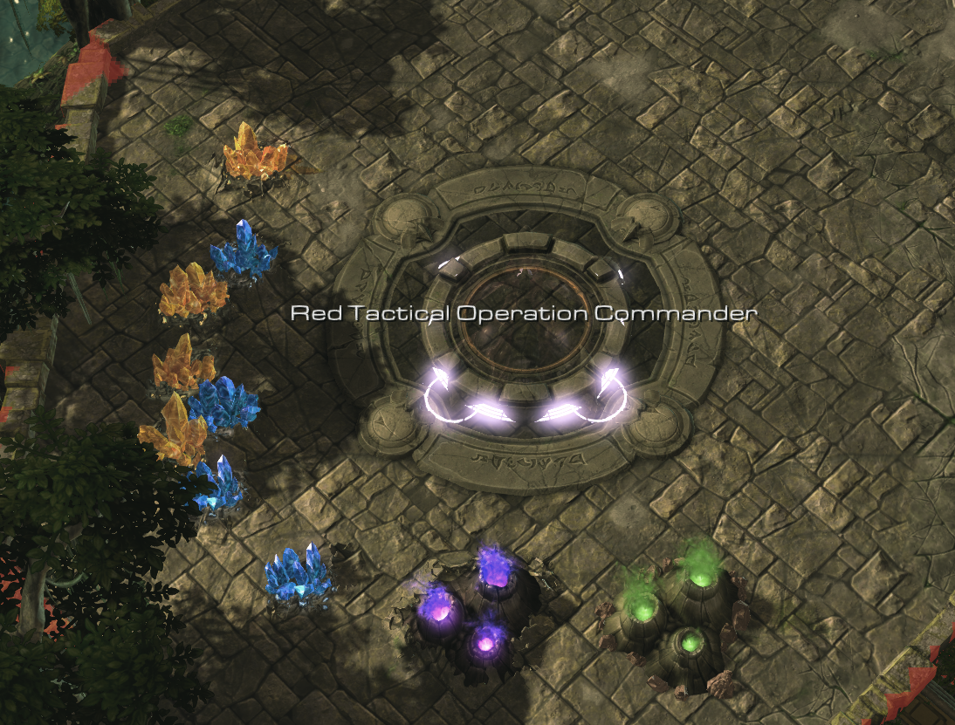

The Sub-Commander's base

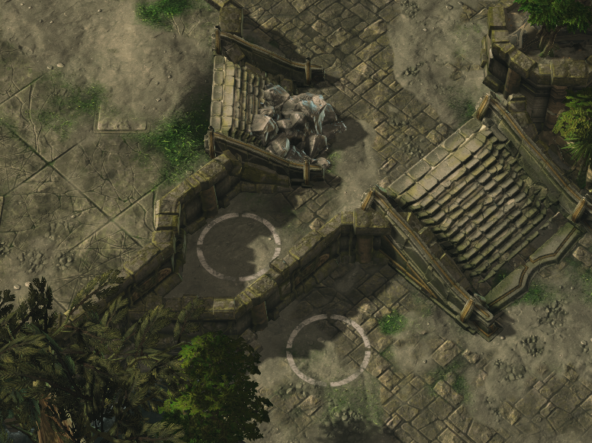

Reaper and hill control terrain at the main entrance of the Vanguard and Weapon commander

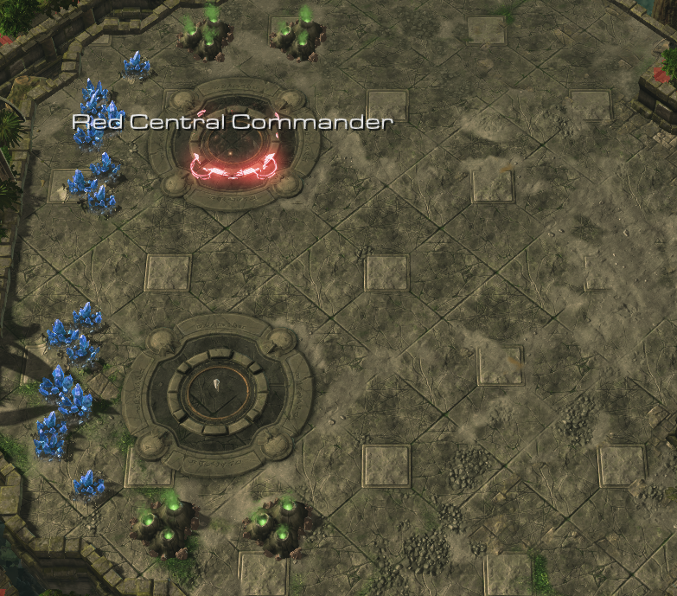

Vast Central Commander Terrain

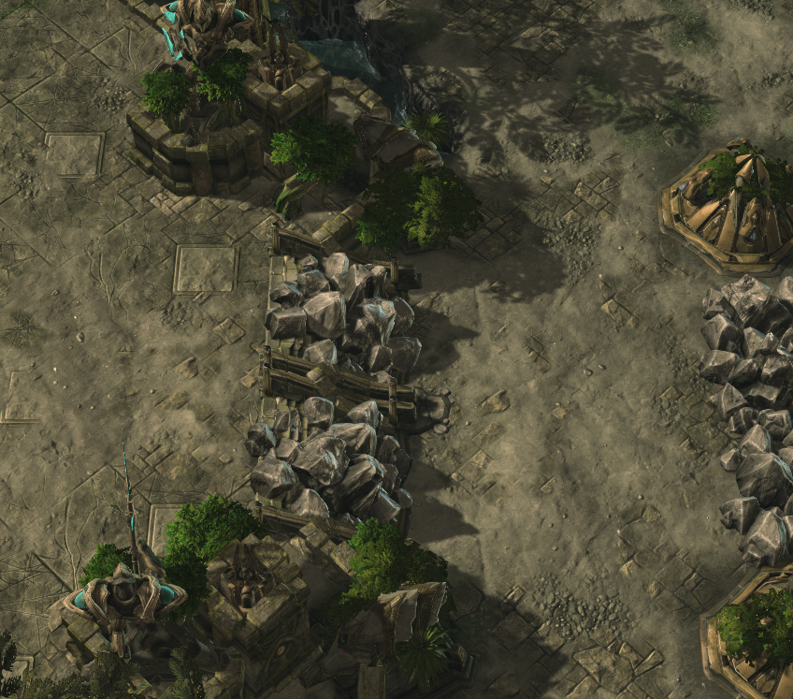

The entrance to the Central Command building is blocked by rubble (HP 2000)

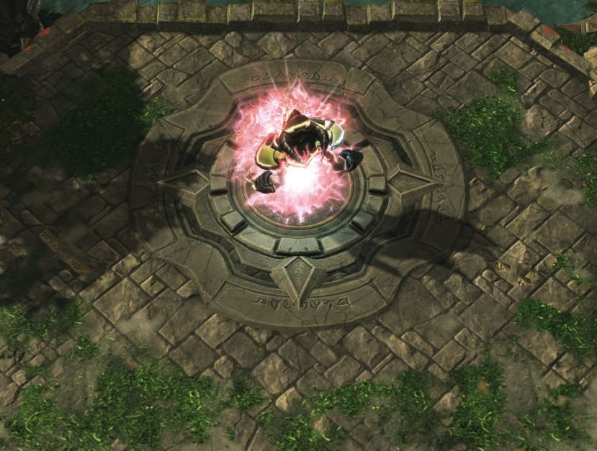

A Dark Archon is deployed at 12 o'clock on the battlefield. (7 minutes after the start of the game, 1800 shield, 300 HP) Upon killing, 2 defense, 2 health regeneration, and 1.5x move speed buff are provided for 3 minutes. It reappears 4 minutes after being eliminated.

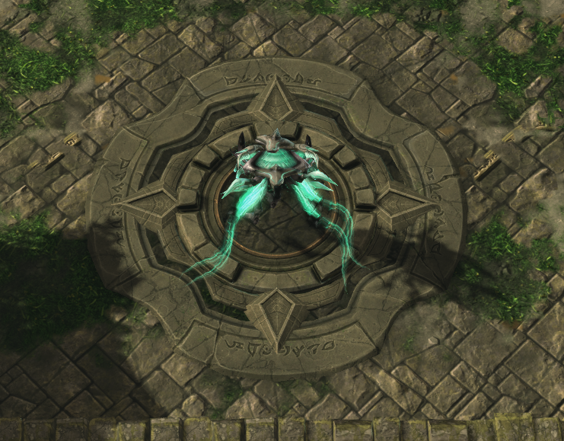

A hybrid is deployed in the 6 o'clock area of ​​the battlefield. (9 minutes after starting the game, 1000 shield, 1000 HP) Upon killing, 2 attack power, 1 range, and 1.5x attack speed buff are provided for 3 minutes. They reappear 4 minutes after being eliminated.

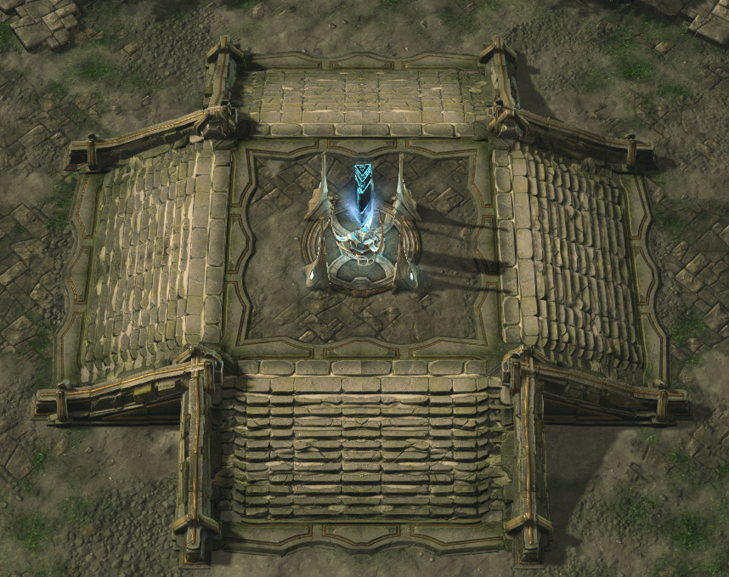

A Keystone placed in the middle of the map

A unit approaches and performs a Keystone charge.

# Ⅳ. End Game Scenario

First Scenario - Surrender (gg Declaration)

Second Scenario - Destroy all enemy structures (Eliminated)

Final Scenario - Activate the Keystone

The third scenario in this game is implemented as a use map trigger. So there may be errors, but so far I haven't had one.

The most important object Keystone is placed in the center of the map. And the Keystone provides all users with a view of their surroundings.

The user brings even one unit closer to the placed Keystone. -> Press the button on the top right to recharge the Keystone by using 500 minerals and 500 gas each. -> If you defend the Keystone with 3000 HP for 3 minutes, the Keystone will activate and eliminate all enemies. -> If it fails, the Keystone resets and can be recharged after 30 seconds.

[참고 영상](https://youtu.be/C5btvBQQSuQ?t=858)

# Ⅴ. The End

It was fun to reassemble various units and skills like a puzzle. However, my main focus was on completing the Third Melee condition. If you look at the overall strategic games of the present era, including this game, you have to go out of the map and toward a cycle located in a corner.

I wanted to suggest that Melee conditions are not always located outside the map, but can also be located in the middle of the map. And in fact, this position is often employed in games that compete for multiple FPS or missions. It is often referred to as the concept of high terrain.

However, this map will have to handle a huge number of units (150 * 2 (Tactical & Support) + 180 * 2 (Vanguard & Weapon) + 200 (Central)) * 2 (both teams). This is a limit that was raised to the limit so that you can hit hard.(If you want more, it's open to the public, so touch the trigger and lift the limit on the population or resources... If it's lagging, you can change your computer or contact Blizzard. I don't know about that;;)

I made this game because I was bored. However, I don't think I'll get bored from March next month. So, it may be difficult to update new panel skills or contents. I'm going to get a numerical balance or a bug in this map.(There are more bugs than I thought :( ) It really does get content updates from time to time.

This post will be shared between two sites that were of great help at the beginning of production and those that were of great help to the end.

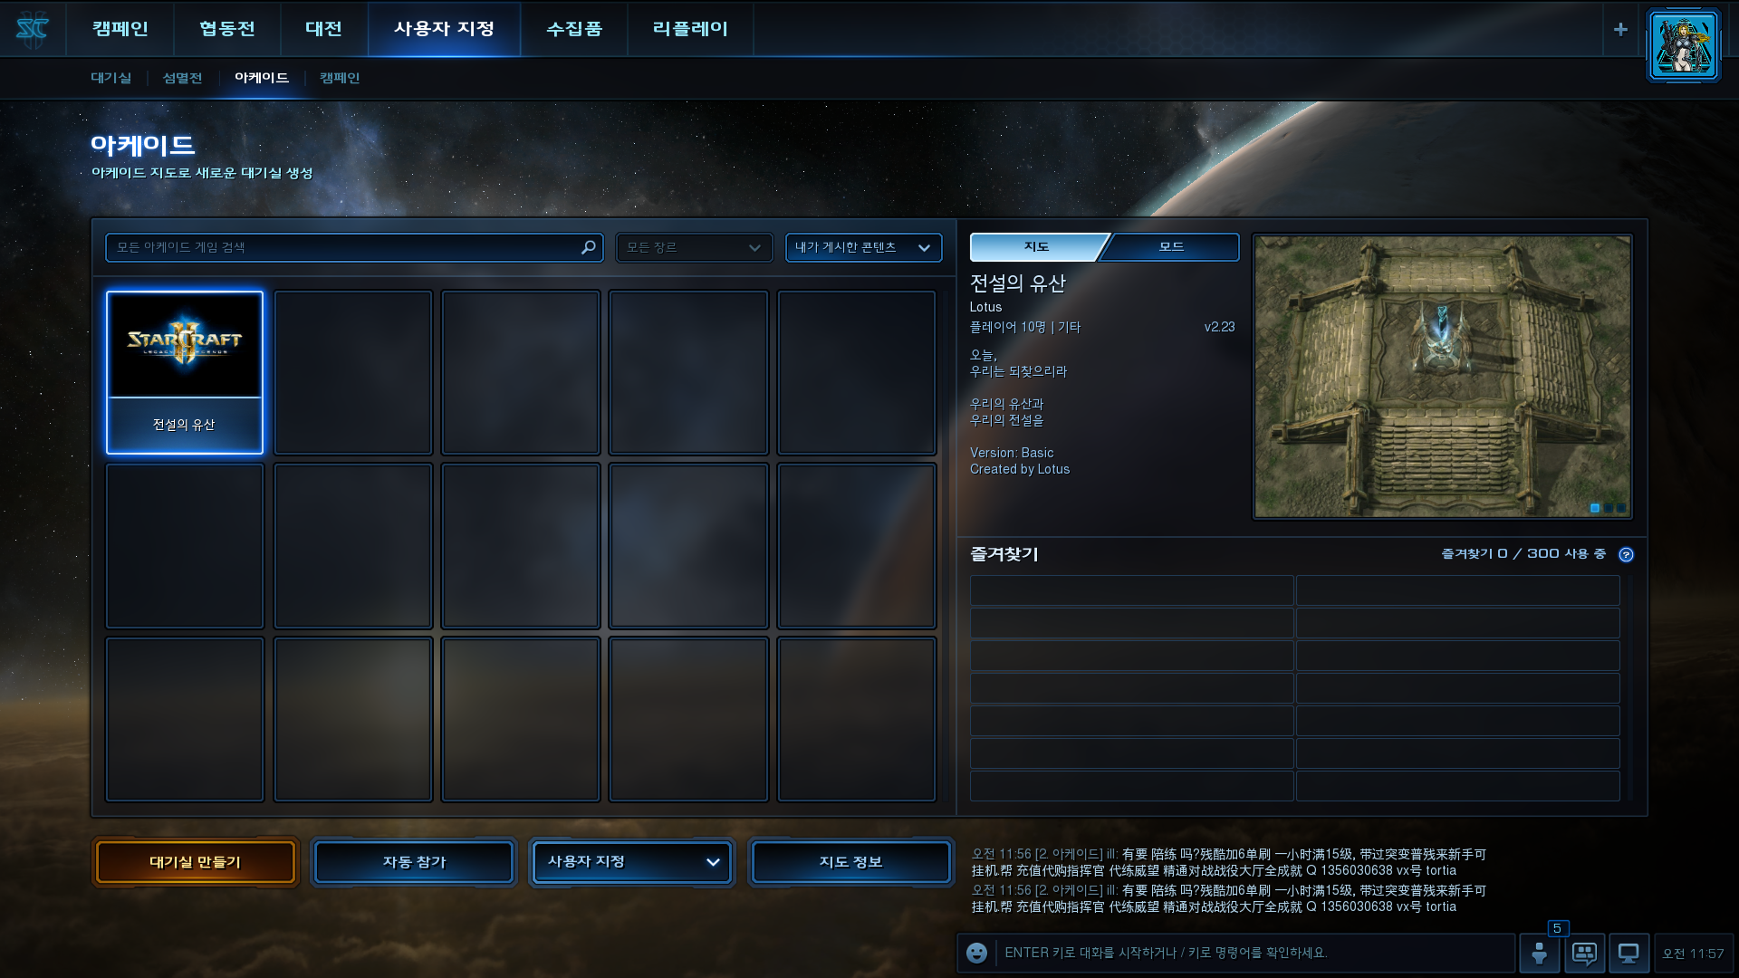

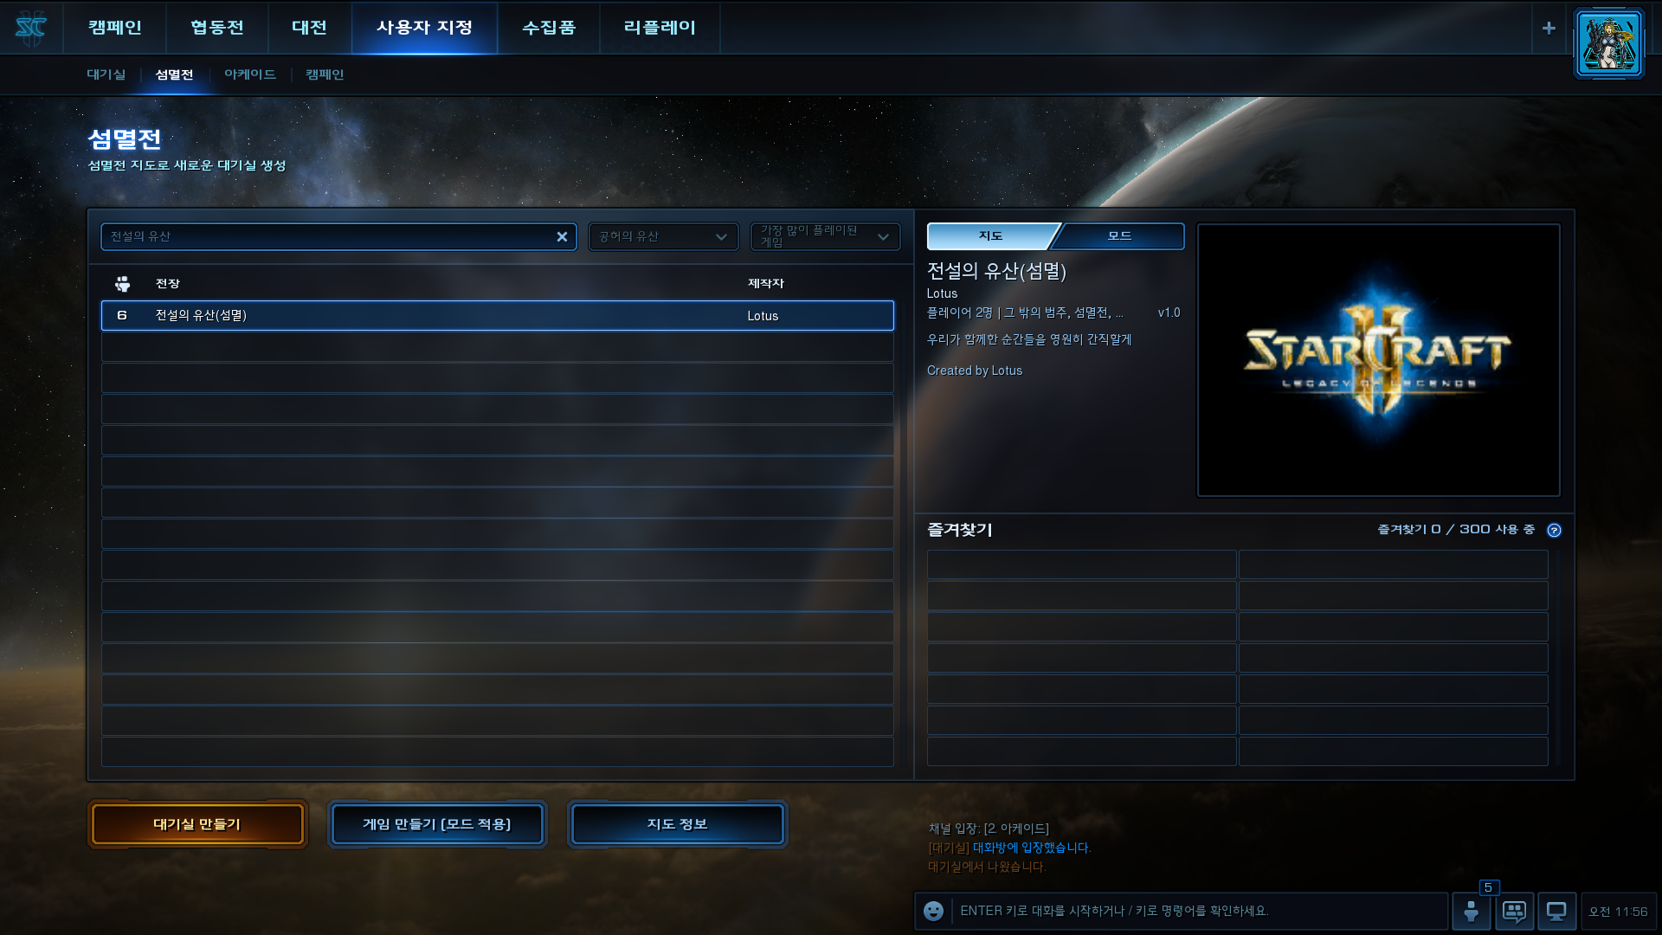

This map is published on the StarCraft 2 Arcade Bulletin and shares the annihilation terrain with the basic outline completed during development. (I don't know why, but only the Asian server is uploaded. It's annoying to find out. Do it yourself.)

I hope you have a fun production and play.

This post was written with the help of an artificial intelligence translator. The sentences were reviewed by me myself, so some words or idioms might have been used with errors and different words from the original. I ask for your understanding.